PROBLEM STATEMENT-
User Story: As a casual JioHotstar subscriber, I want to quickly discover content that matches my current mood so that I don't waste my limited free time scrolling through endless catalogs. Business Impact: The current "paradox of choice" results in prolonged browsing times (averaging 15 minutes), elevated session drop-offs, and a direct increase in subscription cancellations from unengaged users.

Goals
- Reduce the average time-to-play (TTP) from the current 15 minutes down to [insert target, e.g., < 5 minutes].
- Increase the session-to-play conversion rate (the percentage of browsing sessions that result in a user watching a title for at least 5 minutes).
- Decrease the "zero-watch" session rate (the percentage of sessions where a user opens the app, browses, and exits without playing any video).

Non-Goals
- Developing a short-form, scrollable video feed (e.g., TikTok/Reels clone) to artificially boost quick engagement.
- Reducing the overall size of the content catalog or removing niche categories to simplify user choice.
- Solving the issue via content acquisition (e.g., buying the rights to new movies or shows).
- A complete redesign of the core home screen UI.

SUCCESS METRICS - .
North Star Metric: Session-to-Play Conversion Rate (The percentage of total app sessions that result in a user watching a movie or series for at least 5 minutes. This proves users are actually finding something they want to watch.)
L1 Metric (Primary Indicator): Average Time-to-Play (TTP) (The average time a user spends browsing from app open to pressing play on a title. The target is to reduce this to under 5 minutes.)
L2 Metric (Secondary Indicator): Zero-Watch Session Rate (The percentage of sessions where a user opens the app, browses, and exits without playing any video.)
Counter Metric: Early Abandonment Rate (The percentage of users who start a movie/series but exit within the first 3 minutes. This ensures that while we are helping them decide faster, we aren't just tricking them into clicking play on bad recommendations.)

USER PERSONA
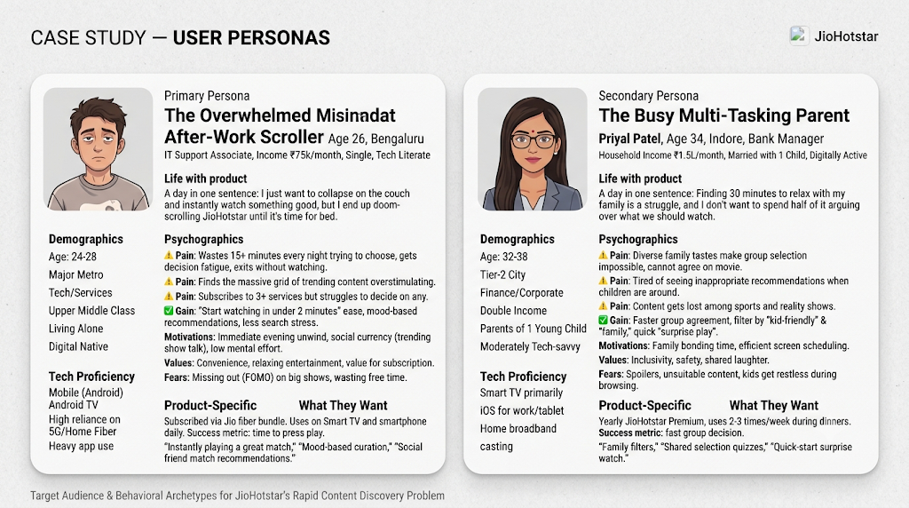

USER JOURNEY -
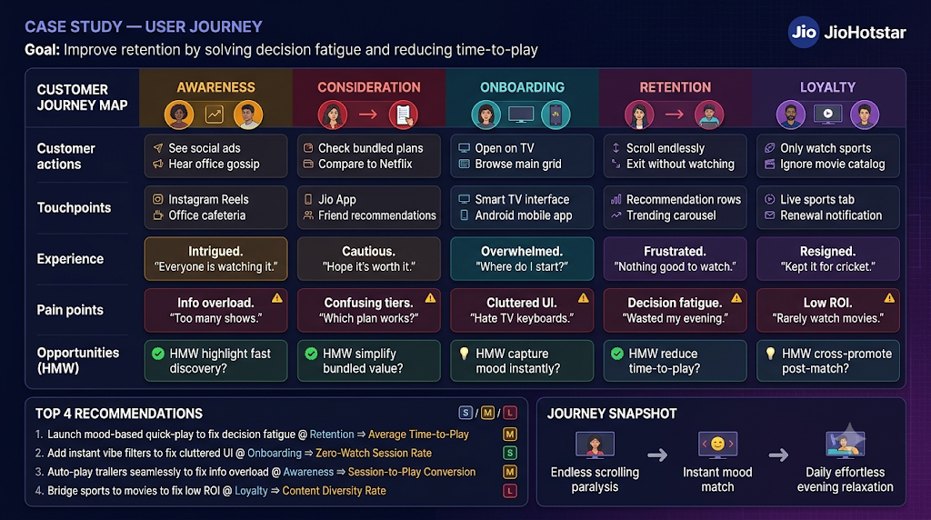

User empathy map
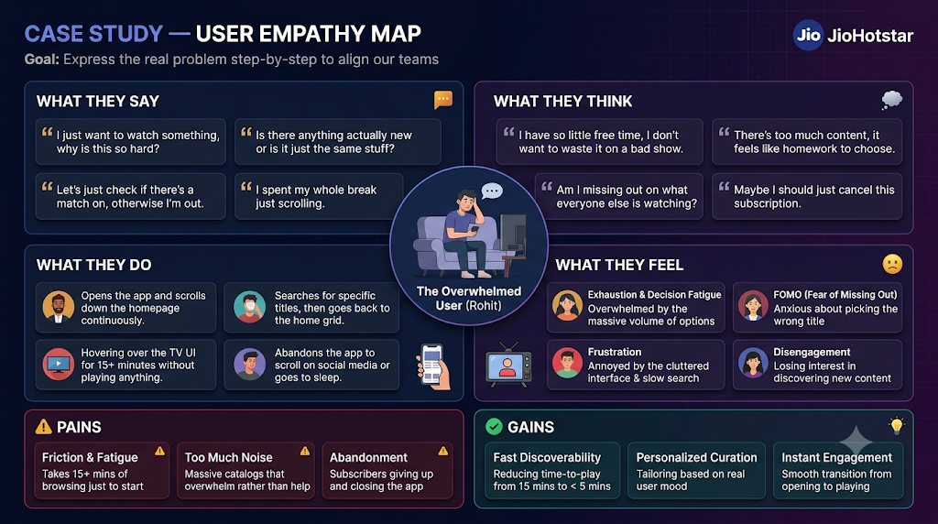

RICE Prioritization Matrix

Feature / Proposed Solution | Reach | Impact | Confidence | Effort | RICE Score (PRIORITY)
1. Algorithmic Match Quality Scoring (%) | high | high | medium | medium | P0
2. AI-Powered Semantic Search | medium | high | medium | high | P1
3. Mobile Short-Form Trailer Feeds | medium | HIGH | medium | high | P2
4. Granular "Mood" Hubs like rainy mood etc. | medium | medium | medium | medium | P3

Functional Requirements (FRs)
- The system must calculate and display a "Match Percentage" (e.g., 94%) for each video title based on the user’s implicit watch history, explicitly stated tastes, and content metadata.
- The UI must display an informational tooltip (Transparency) explaining the inputs driving the match score when tapped.

Non-Functional Requirements (NFRs)
- Performance: The match score must render on the client UI in under 200ms alongside the video thumbnail.
- Scalability (Quantity): The backend must be capable of pre-calculating and caching match scores for the top 500 trending catalog items per active user session.
- Reliability (Fallback): The feature must have graceful degradation; if the recommendation microservice times out, the app must load the standard UI without the match score rather than blocking the user's session.
- Security & Privacy: All watch history ingested by the algorithmic model must be stripped of Personally Identifiable Information (PII) during processing.
Usability: The score must require 0 clicks to view, integrated directly into the default un-expanded thumbnail view.

